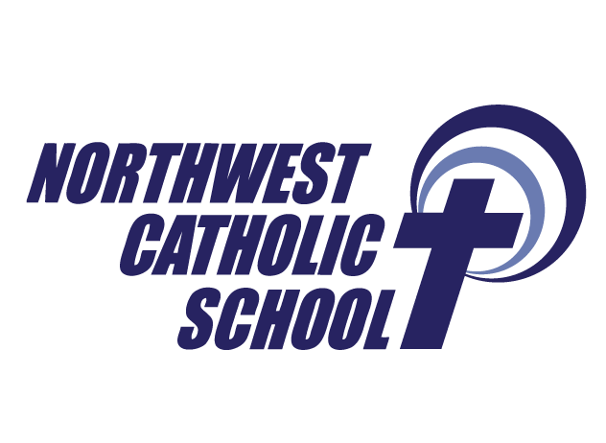
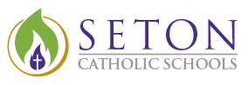

KNIGHTLY NEWS
Respectful, Responsible, Ready to Shine
July 24, 2019

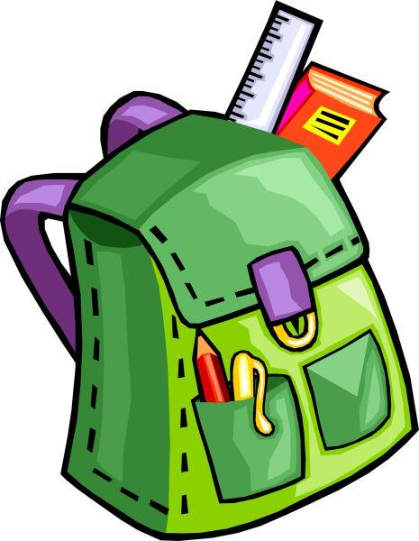
Meet and Greet- August 20
Join us for Meet and Greet on Tuesday, August 20. Stop by anytime between 1:00-4:00pm to meet your teacher and drop off school supplies! We are excited to see you. REMEMBER THE FIRST DAY OF SCHOOL IS MONDAY AUGUST 26!

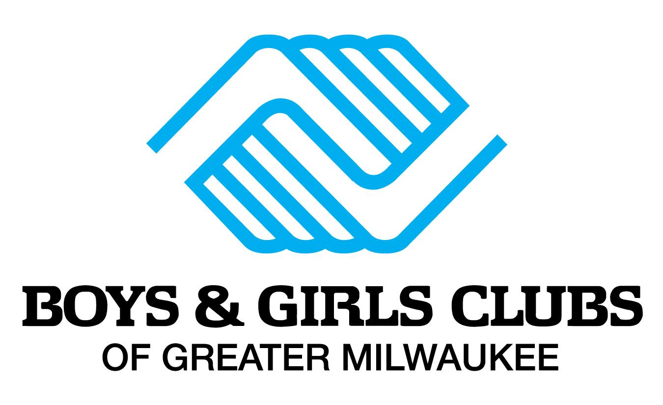
Boys & Girls Club at Northwest Catholic!
We are excited to be partnering with Boys & Girls Club of Milwaukee for our after school program this school year starting August 26! They will be providing academic support as well as a variety of fun activities for all grade levels. They will be at Meet & Greet to answer any questions and register all interested families.

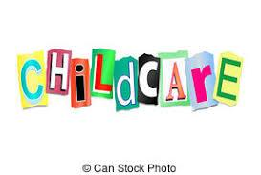
BEFORE SCHOOL CARE
Information regarding our Before School Care and After School Program will be emailed to you the early part of August.

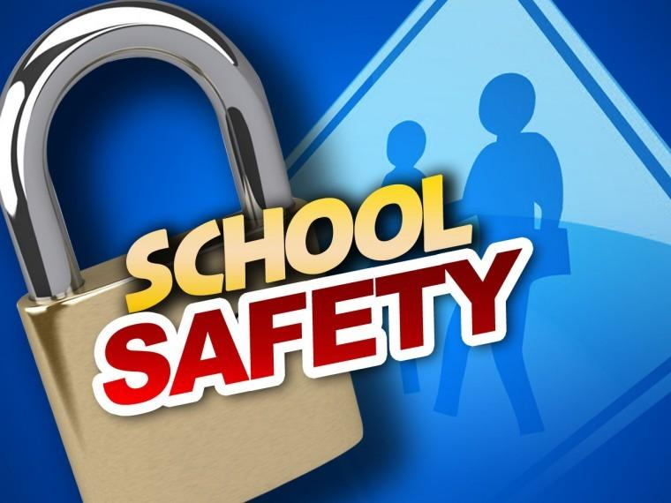
Secure School Entrance
Construction for an enhanced secured school entrance will begin the end of the month. The project is part of the Department of Justice Safety Grant. A secondary wall and locked door will be constructed as well as office space near the entrance. The project is expected to take three weeks.

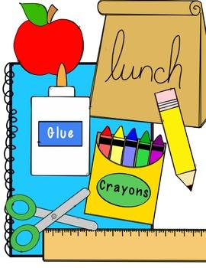
Spread the word-get rewarded!
Invite your family and friends to enroll at Northwest Catholic School for the upcoming school year and be eligible for a gift! To get started, (1) refer an interested family or friend; (2) have them enroll for the upcoming school year; (3) you will receive a backpack filled with school supplies. For more information, contact Linda Goeden 414-352-6927 ext. 301. With your help, we look forward to growing our school community!

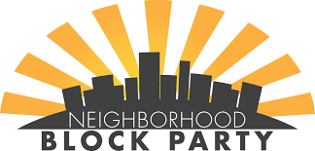
JOIN US FOR A BLOCK PARTY!
Northwest Catholic School is hosting a Neighborhood Block Party on Thursday, August 8, from 5:00pm - 7:00pm (Food served until 6:30pm). The party is located the Our Lady of Good Hope church parking lot on the corner 41st and Good Hope Rd. Come join us from food from Jericho’s BBQ, games, music, snow cones, and a 6:30pm performance from the Milwaukee Flyers! Hop to see you there.

August
August 8 -Block Party
August 20 - Meet and Greet
August 26 - First day of School
Northwest Catholic School Mission Statement
Northwest Catholic School serves a diverse urban community through strong academics and service rooted in the Catholic tradition. We form productive citizens who live the message of Jesus Christ.

